The objective of LSP Renewables is to service the international renewable energy industry covering permanent and contract positions across the full spectrum of renewable energy sources. To achieve this objective, LSP Renewables will maintain an effective and efficient Quality Management System (QMS) that is certified by a UKAS-accredited Certification Body as compliant with ISO 9001. | 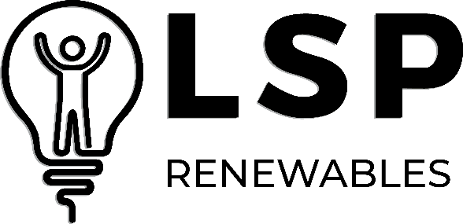  delighting our customers is fundamental to our operations
As such, the Directors of LSP Renewables are committed to the following:
- Establish measurable quality and business objectives that are consistent with our context and strategic direction and to address risks and opportunities associated with them.
- Ensure quality objectives help us achieve customer requirements.
- Proactively seek feedback from customers on how well our products and services meet their requirements and set objectives for continual improvement.
- Analyse the causes of any complaint or problem and take action to prevent recurrence.
- Ensure we comply with all applicable legal, regulatory, contractual, and other third-party requirements.
- Monitor and measure the effectiveness of business processes and objectives through internal audit and management review processes.
- Select and work closely with suppliers who help us create and deliver a reliable performance.
- Support employees to identify and undertake appropriate training as part of continued development of the competency of all employees.
- Encourage all employees to identify problems and make suggestions to improve all aspects of our services, and business processes.
- Ensure all our employees are aware of the Quality Policy and are committed to the effective maintenance of the QMS.
- Ensuring the impacts of climate change on our operations are assessed and acted upon as appropriate, as well as minimising the impacts on climate change resulting from our activities to help protect the environment.
The continual improvement of the LSP Renewables QMS is fundamental to our success and must be supported by all employees as an integral part of their daily work.
This policy is publicly available to interested external parties upon request.
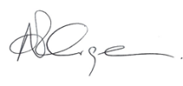
Adam Grainger, CEO
January 2026

