Our company activities interact with the environment in a variety of ways. To ensure we identify and assess each interaction, we have adopted a lifecycle perspective that helps us understand each of our direct and indirect impacts on the environment.  We recognise our activities can have a significant environmental impact in the key areas of energy use and generation of waste materials. | 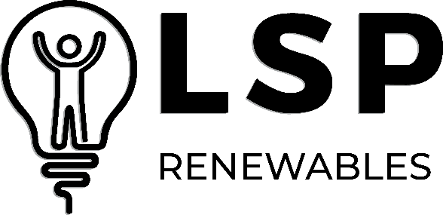  We have a responsibility to help protect the environment wherever possible
As such, the Directors of LSP Renewables are committed to the following:
- Continual improvement in the environmental impact of our business activities.
- Improving the environmental benefits provided by our products and services.
- Protecting the environment, including preventing pollution.
- Ensuring we comply with all applicable legal, regulatory, contractual, and other third-party requirements.
- Establishing measurable environmental and business objectives that are consistent with our context and strategic direction and addressing associated risks and opportunities.
- Achieving objectives to help minimise our environmental impact, including those that may have a contribution to long-term environmental considerations (including climate change).
- Adopting best practices applicable to our activities wherever practicable.
LSP Renewables will meet these commitments by:
- Implementing and maintaining an Environmental Management System that is certified by a UKAS-accredited Certification Body as compliant with ISO 14001.
- Employing processes that identify the aspects of our business that have an environmental impact and assessing the significance of each aspect to enable us to reduce their impact.
- Maintaining an environmental performance improvement programme to enable us to achieve our objectives.
- Ensuring that our employees, suppliers, and customers are aware of their role in supporting our commitments and environmental objectives.
- Training our employees in good environmental protection practices and encouraging employee involvement in environmental improvement initiatives.
- Continually monitoring the environmental impact of our business activities.
This policy is publicly available to interested external parties upon request.
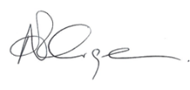
Adam Grainger, CEO
January 2026

